**Using ohai in templates**

**Step 0 :Perform below commands**

ohai

ohai cpu

ohai memory

##### **Step 1: create a template under httpdcookbook**

# vim /home/ubuntu/chef-repo/cookbooks/httpd/templates/default/monitoring.html

Copy the below content

<html>

<body>

<h1> Hello!!!!!!! from <%= node["hostname"] %>! </h1>

<h1> this is active memory you have <%= node["memory"]["active"] %>! </h1>

<h1> this is inactive memory you have <%= node["memory"]["inactive"] %>! </h1>

<h1> My uptime is <%= node["uptime"] %>! </h1>

<h1> My mac address is <%= node['macaddress'] %>! </h1>

<h1> my fqdn is <%= node["fqdn"] %>! </h1>

<h1> I am running operating system version <%= node["lsb"] %>! </h1>

<h1> I am running as guest os on virtualization platform of <%= node["virtualization"] %>! </h1>

<h1> my cpu detials <%= node["cpu"] %>! </h1>

</body>

</html>

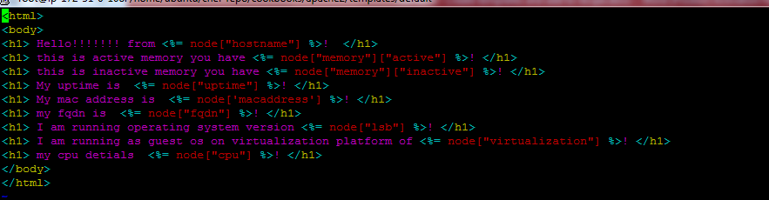

##### **Step 2 : Edit your apache2 default recipe and add template**

vim /home/ubuntu/chef-repo/cookbooks/httpd/recipes/default.rb

template "/var/www/html/monitoring.html" do

source "monitoring.html"

mode "0644"

end

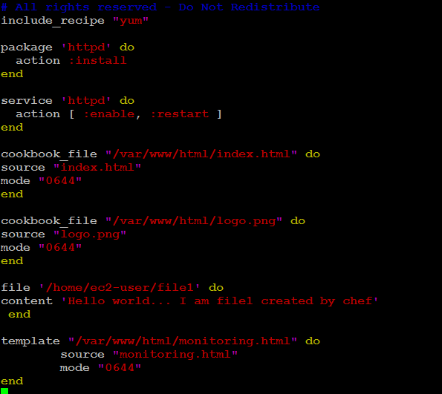

**Step 3 : upload httpd cookbook**

knife cookbook upload httpd

## Step 4: Login into rhel node from your workstation

ssh -i "ibm-public-key.pem" [ec2-user@ec2-52-67-119-162.sa-east-1.compute.amazonaws.com](mailto:ec2-user@ec2-52-67-119-162.sa-east-1.compute.amazonaws.com)

**Step 4 : ( this time we will do pull request)**

# sudo chef-client

**Step 5 : Open a web browser to check template is applied or not**

Note : replace the below DNS name with your chef node ec2 instance

http://ec2-54-183-89-234.us-west-1.compute.amazonaws.com/monitoring.html

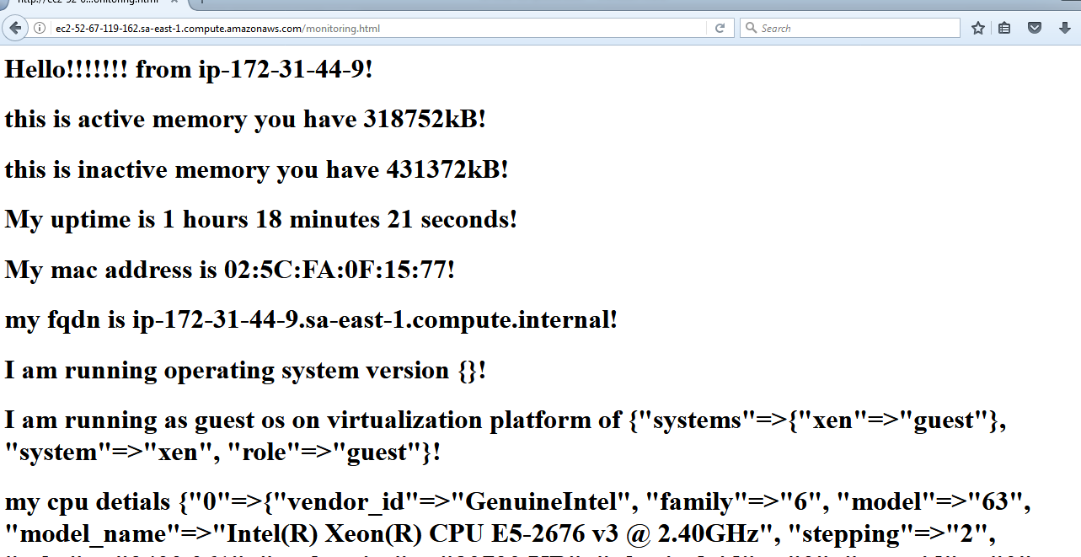

<https://docs.chef.io/plugin_knife_custom.html>

<https://docs.chef.io/plugin_community.html#knife>